A FRAMEWORK FOR IMPLEMENTING CORPORATE WEBSITES IN SCHOOLS
Writer - Fine Bhebhe
Co-writer - Khesani Richard Chilumani
Abstract
The online presence of Zimbabwean schools is low. Zimbabwean schools are not taking the corporate website technology as a tool they can use to better their service delivery system and advance their cause since this will be their virtual face and likely to be the first access point by online visitors. The corporate website technology has the potential to be a cost-efficient medium schools can use for their communication purposes. The study was to determine whether this low uptake of the technology is due to the schools authorities’ perception that this technology is not user friendly, which in itself stems from computer illiteracy on the part of the same schools authorities. Computer illiteracy is the inability to achieve a desired outcome through the use of computers. This goes further to even influence the schools authorities into viewing the technology as a useless technology not worth the resources invested in. Even upon investing in the technology, the intention to use the technology to its full potential would not be there because a system that does not help an individual to perform their job most likely they will not perceive it as useful. The research took the positivism paradigm approach, and premise on the Technology Acceptance Model (TAM). It takes cross-sectional survey as the research tool. The collected data was inputted into the Statistical and Presentation System Software (SPSS) and the output results analysed. Guided by the analysis of the output results, a relevant and workable framework for schools to use so as to implement and maintain their corporate websites was developed

Keywords: schools authorities, corporate website, Framework
- Background
The globalisation of markets and fast changes in the global economy have forced organisations to use technology and information and communication systems (Leyh 2016. p. 7). Zimbabwean schools, especially the formerly “Group A Schools” during the colonial era, are backed by their rich history and an array of alumni they can use to profile themselves and solicit for financial assistance needed to spruce up their deplorable images. The spread of the Internet has provided a unique opportunity for organisations to conduct their businesses electronically and thus be competitive (Hooshang et al, 2007). If owned, a corporate website becomes the virtual face of an organisation (Chulkov & Zhang 2008). Online presence, especially in the form of corporate website ownership and can be an avenue for these schools to get the exposure they need. In the developing countries schools are being run down by the day and responsible authorities are leaving the status quo. These schools happen to serve the majority of the school going children (Kumar & Sarangpani 2011).

- Introduction
A scenario whereby schools fail to handle digital information has a cascading effect on schools giving little or no time at all to teachers to manage and familiarise themselves with Information and Communication Technology in this era where e-learning is gathering pace world over (Odunayo & Otito 2013). In Zimbabwe, while Government schools authorities acknowledge the importance of an online presence, they are however uncomfortable on the subject matter due to the non-availability of a framework that can assist them to achieve this. Most headmasters/ mistresses running Government schools in Zimbabwean are not the digital natives generation, and therefore are not technically sound in that regard (Netregistry 2016).

- Objective
In order to appreciate the level of computer appreciation skills among government schools in Zimbabwe so as to offer an appropriate and relevant framework that will help schools authorities setup and manage corporate websites for their schools, the study was guided by the primary objective of establishing whether the perceived ease of use of corporate websites by the schools authorities affects their behaviour in the form of the intention to use them.

3.1 Secondary Objectives
The secondary objectives were to: -
    - Determine whether the perceived ease of use and the perceived usefulness of corporate websites by the schools authorities is influenced by their computing background;
    - Determine whether there is a relationship between the perceived ease of use of corporate websites and their perceived usefulness to the schools authorities;
    - Establish whether the perceived usefulness of corporate websites to the schools authorities affects their behavioural intentions.

  - Research Questions
The study was guided by the primary question of finding out whether if corporate websites are user friendly, would schools authorities be willing to own them?
The secondary research questions were: -
    - What are the computing backgrounds of the schools authorities?
    - How are the current users of schools corporate websites finding them in terms of user friendliness and usefulness?
    - If corporate websites are useful, to what extent are schools authorities willing to use them?

  - Hypothesis
H₀: Schools authorities who view corporate websites as user friendly are willing to exploit them to their full potential.
H₁: Lack of strong computing background on the part of schools authorities has a negative effect on their perception of user friendliness and usefulness of corporate websites.
H₂: There is a positive relationship between perceived ease of use and perceived usefulness of corporate websites.
H₃: Schools authorities who view corporate websites as useful are willing to exploit them to their full potential.

- Literature Review
Computer literacy can be taken as the ability to achieve a desired outcome through the use of a computer. This entails the ability to operate a computer and to understand the language used in working with a specific system or systems (Maria-Gorretti & Kenneth 2012). A computer self-efficacy, is an individual’s perceptions of their ability to use computers in the accomplishment of a task (Mohd 2009). Experienced computer users have a higher computer self-efficacy and lower computer anxiety (Chien 2008).

Researchers (Davis et al., (1989); Mathieson, (1991); Gefen & Straub (2000); and Gahtani, (2001) in Jahangir & Begum (2008) all agree that perceived ease of use is the extent to which a person accepts as true that using an exacting method would be at no cost to that individual. A system that does not help people perform their jobs is not likely to be perceived as useful, and that perceived usefulness directly influences computer usage by an individual (Nysveen et al 2005) in Mohd 2009). A high computer self-efficacy has a positive impact on an individual’s perceived ease of use (Mohd 2009).

Corporate website maintenance has to do with safeguarding the operational integrity of a corporate website and ensuring that it is running smoothly and according to plan (Diffily 2016). At the same time, perceived ease of use and perceived usefulness do affect an individual’s technological adaptation intentions (Chen & Barnes 2007 in Jahangir & Begum 2008). With this fact in mind, it is encouraging to note that neither proprietary software nor specialised expertise like in Hyper Text Markup Language (HTML) is required from an individual who maintains the content of their corporate website (Powell & Gill 2003).

A corporate website framework can be taken as a pre-built template that handles most of the repetitive or common features on the corporate website and does not necessarily has to have a user interface (Cassim 2013). As a result, the main objective of a corporate website framework is to allow corporate website owners and designers to focus on building the unique features in the corporate websites as opposed to re-inventing the wheel. A poorly designed and/ or maintained corporate website can actually do more harm than good to an organisation (Chulkov & Zhang 2008). On the other hand, a well-designed corporate website, updated with a user-friendly interface, presenting the information in a clear and concise manner attract new and repeat visitors, thus creating loyalty to the corporate website (Powell & Gill 2003). They further underscore the need for continuous and regular updates and maintenance because after becoming familiar with what they can find and how they can find it, corporate website visitors tend to expect more and in a timelier manner from that particular corporate website.

- Theoretical Framework
In general, a theoretical framework guides research and determines what variables to measure as well as the statistical relationships to look for. The research was premised on the Technology Acceptance Model (TAM) theory. TAM implies that when users are presented with a new technology, an individual’s behaviour is motivated by some behavioural objectives which are a function of an individual’s attitude toward the behaviour and subjective norms surrounding the performance of the behaviour (Surendran 2012).

He further explains that two factors that are at play in as far as the TAM model is concerned are:
- Perceived Usefulness (PU) of the technology – which is the degree to which a user believes that using a particular technology / system, would enhance their job performance.
- Perceived Ease of Use (PEOU) of the technology - which is the degree to which a user believes that using a particular technology / system would be free of effort.
External Variables
Perceived Ease of Use
Actual System Use
Behavioural Intention
Perceived Usefulness

Figure 1: Technology Acceptance Model (Surendran, 2012)

- Research Design and Data Collection
The study premise cross-sectional survey of schools as the research designed. Cross-sectional surveys are carried out at just one point in time, and they give a snapshot of what is happening on the group at a particular point in time (Mathers et al 2009). Cluster sampling was used which, Mathers et al (2009) explains as a method frequently employed in national surveys where it is uneconomic to carry out interviews with individuals scattered across the country. The study followed three methods of collecting the data for these surveys which are face-to-face interviews, telephone interviews and questionnaires.

Data was collected at selected schools from Bulawayo Metropolitan Province, Matabeleland North Province, as well as Matabeleland South Province. The key respondents per school were the School Heads, Deputy Heads and Teachers in Charge (TIC’s)/ Heads of Departments (HoD’s). Primary schools in the Matabeleland North, Matabeleland South and Bulawayo that had corporate websites already working, regardless of whether those corporate websites were optimally functional or not were used in the survey. The schools chosen also had computer laboratories and had computer teachers who specialise in teaching computers.

6.1 Research Findings
A total of forty one (40) questionnaires were sent out to respondents, i.e. four (4) per school – one per each for the school head, the teacher in charge, and the computer teacher. Out of these, thirty five (35) were completed and five (5) were done telephonically. The response rate of the questionnaire was one hundred percent (100%) for the chosen schools. Schools were chosen on the basis of having a school corporate website already in place for the utilization of the Technology Acceptance Model (TAM) as the theoretic framework.

6.2 Survey Response
Below is an indication of how the response was like from the respondents of the questionnaire survey conducted at the schools: -

Table 1: Questionnaire with quantities of respondents
PART | Q U E S T I O N | S C A L E
 |  | 1 | 2 | 3 | 4 | 5
1 | User Computing Background
 | - On a 1 – 5 scale, how would you rate your computer skill level? | 16 | 14 | 6 | 4 | 0
 | - You are very confident with computers. | 14 | 18 | 6 | 2 | 0
 | - On a daily basis, you frequently use a computer. | 26 | 8 | 0 | 6 | 0
 | - At home, outside of business hours you often use a personal computer. | 30 | 4 | 0 | 4 | 2
2 | Perceived Usefulness of own Corporate website
 | - Since owning a corporate website your school is better positioned and more effective in carrying out of its duties. | 8 | 14 | 12 | 2 | 4
 | - You would never think of discontinuing the use of your school corporate website. | 6 | 12 | 16 | 0 | 6
 | - The school stakeholders are getting invaluable information as they access and interact with your school corporate website. | 10 | 14 | 8 | 2 | 6
3 | Perceived Ease of Use of own Corporate website
 | - You find the task of updating your school corporate website easy and understandable. | 22 | 8 | 4 | 4 | 5
 | - You rarely find yourself seeking help in order to successfully update your corporate website. | 18 | 8 | 12 | 2 | 0
 | - You can update and/ or navigate through your corporate website within a short space of time. | 16 | 12 | 8 | 0 | 4
4 | Behavioral Intention to use
 | - Currently, you frequently update your corporate website. | 16 | 8 | 10 | 2 | 4
 | - In future you intend to frequently update your corporate website. | 10 | 6 | 12 | 4 | 8
Source: Primary Data
25% strongly disagree with view that they possess adequate computer appreciation skills, whilst 30% also disagree. This gives a total of 55% of the respondents disagreeing with this view of possessing adequate computer appreciation skills. Another 20% can easily fall into this group as they are undecided. Only a quarter (25%) agree that they have the computing skills. In other words, their usage both at work and home is also below average. The ideal situation (Benchmark) for any index is 105, meaning 50% of that is 52.5. For all the aspects of computing background, the average would be less than that 52.5 halfway mark.

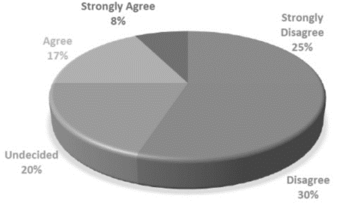
Figure 2: Respondents’ Computing Skills (Primary Data)
A significant percentage of 42% will definitely not use the computer after work. Another 12% do not see themselves using a computer that much after work. Together with those that are indifferent on this matter (15%), a total of 69% do not make a computer part of their private life.
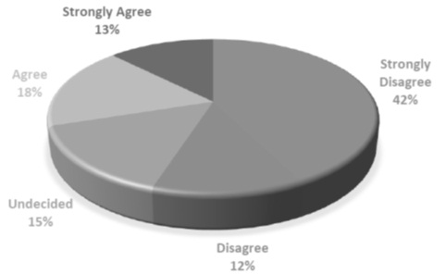
Figure 3: Respondents’ Computer Usage after Work (Primary Data)

For computer skills the mode (most ticked answer) is 2, which indicates that they disagree with the view. For computer confidence the mode also is 2, which again indicates that they disagree with the view. For daily computer usage the mode is 1, which indicates that they strongly disagree with the view.
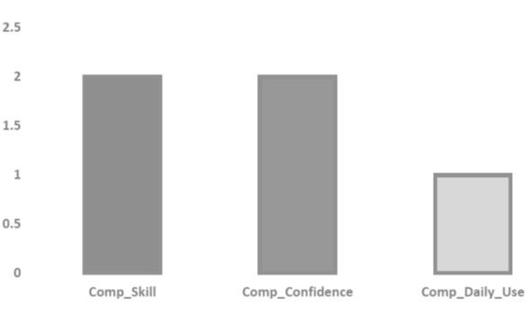
Figure 4: Respondents’ Computer Interactiveness (Primary Data)

43% of them are sitting on the fence, being not convinced that this is a useful technology to their schools, but at the same time non dismissal to the fact. But if the 7% who strongly disagree and the 27% who disagree (giving us a total of 34%) are taken on board, then we have only 23% seeing the corporate websites being beneficial to their schools (i.e. 8% strongly agreeing and 15% agreeing). 42% of the respondents do not see corporate websites as a useful technology to the schools’ stakeholders.

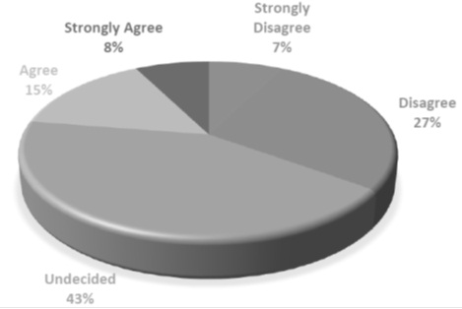
Figure 5: Respondents’ Corporate website Usefulness (Primary Data)
35% strongly disagree with the view that that is an easy exercise, whilst another 20% disagree – giving a total of 55%. Taking into consideration the 15% who are undecided, the total of those who do not agree rises to 70%. Those who are positive about the user friendliness are only 30% (i.e. 20% agree and 10% strongly agree). 27.5% seek help (strongly disagree that they update independently without seeking help). Another 25% also dismiss that view (in other words, they do seek help whenever updating). 25% is also sitting on the fence, leaving 22.5% being confident and not seeking help (17.5% agreeing and 5% strongly agreeing).
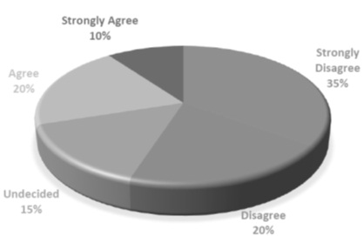
Figure 6: Respondents’ Perception on User Friendliness (Primary Data)

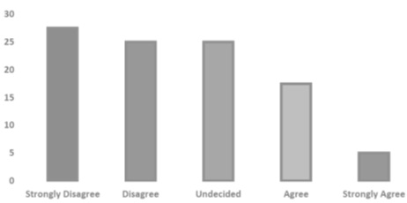
Figure 7: Respondents’ Perception on Ease of Use (Primary Data)

The results from figure 4.8 show that 25% of the respondents do not bother updating the corporate websites, another 20% hardly updates. 35% are not sure whether they will update at all or not. This represents a rejection of the technology by 75% of the respondents.
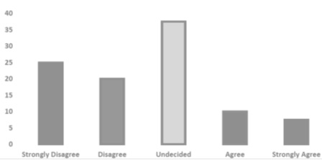
Figure 8: Respondents’ Updating Behaviour (Primary Data)
In each school there is a computer teacher. When the research was conducted, four people were respondents in each school – namely the school head, the deputy head, the teacher in charge and the computer teacher. It means therefore that in each school one respondent out of four (who is the computer teacher) responded with a positive computer background. That therefore explains why 25% of the total respondents have a strong computing background and computer appreciation.

6.3 Results Analysis
As for the other schools’ authorities (the threesome: head, deputy and teacher in charge) do not come near the updating desk. The whole exercise is left to the one individual – the computer teacher, albeit with his or her less authority post. The content therefore is compromised as little importance is placed on it by the offices higher up.

Although apart from the computer teachers, there are some schools authorities who have made computers part of their everyday life - even after working hours, but the percentage of such is still significantly low. Close to 30% of the respondents interact with a computer constantly even after work. This means that apart from the computer teacher teachers who naturally contribute 25% to this figure, only 5% is from the other schools authorities. 42%, which is nearly a half of the correspondents will not use a computer after work. Even in the wake of smart phones, it is assumed that this lot will only use such phones for basic phoning, normal messaging and WhatsApp, without utilizing the internet capabilities.
Since most schools authorities do not bother themselves much with the technology, most of them therefore have not bothered themselves to take stock and see how useful to the school it is. It is sort of a “white elephant”, some phenomenon which happens to be there for the school because some authority (maybe the School Development Committee) recommended it. Whether it works or not – who cares? 43% of the respondents are actually like that. Surprisingly, only 23% take the corporate website as a useful technological tool for the school and its stakeholders. This means that even some computer teachers, who will be updating the information are finding hard to see the use of the technology. The content therefore will be a placeholder, and the updating will be hardly done, and when it is done it will be a hurried and shroud job. For some schools authorities because they are not experiencing the corporate website interaction on a first hand basis, but rather rely on the delegated personnel’s opinion (computer teachers), they cannot fully comprehend and appreciate the technology’s usefulness.

Due to the lacking computing background, and the continued disengage in the use of computers as highlighted earlier on in the analysis of these results, it explains why for most of the schools authorities (55%) find the use of corporate websites a complicated task which is not user friendly. Because there is so much reliance on third parties for assistance to update the information, the task becomes a dreaded one, and those responsible would be happy to ignore it as long as they do not get any pressure from above. Since the popular view from the authorities has been that there is no real benefit to the schools and their stakeholders to have a corporate website, it is highly unlikely that those responsible for updates would get any pressure to do so from above. As a ripple effect also, the updating skills can only get better as one does the task over and over, since those responsible for updating do it once after a long time, their relevant skills would naturally remain unsound, without improving. This also explains why most of them are failing to easily navigate their corporate websites with ease (as per survey results) of which they are supposed to be custodian of – absence of computing skills which will never be improved due to the disengaged and non-committal status quo.

The degree of the users’ willingness to use the technology is very low. 75% of the respondents are not willing to embrace and utilise the technology. This could be the 75% representing the non-computing authorities comprising of the school heads, their deputies and the teachers in charge. The other 25%, which could be the computer teachers are the ones who exhibit some degree of willingness to use the technology.

6.4 Hypothesis Testing
The results of the survey were inputted to the Statistical and Presentation System Software (SPSS) and the cross tabulations were done to determine whether there are any relationships in the variables indicated by the research questions and the questionnaire. The cross tabulation analysis technique used is the Pearson Chi-square analysis. Below are the results of this analysis: -

Hypothesis Revisited
H₀: Schools authorities who view corporate websites as user friendly are willing to exploit them to their full potential.
H₁: Lack of strong computing background on the part of schools authorities has a negative effect on their perception of user friendliness and usefulness of corporate websites.
H₂: There is a positive relationship between perceived ease of use and perceived usefulness of corporate websites.
H₃: Schools authorities who view corporate websites as useful are willing to exploit them to their full potential.
Table 2: Pearson Chi-Square Cross Tabulation Computation Output
Variables Cross Tabulation | Value | df | Asymp. Sig. (2-sided) | Min Exp. Count | Interpretation
Update_Easy * Freq_Update | 28.137ª | 16 | .030 | .30 | Accept H₀
Comp_Skill * Update_Easy  Comp_Skill * Web_n_Duties | 34.631ª  42.212ª | 16  16 | .004  .000 | .30  .23 | Accept H₁
Update_Easy * Web_n_Duties | 32.277ª | 16 | .009 | .30 | Accept H₂
Web_n_Duties * Freq_Update | 28.805ª | 16 | .025 | .23 | Accept H₃
Source: Secondary Data

- The Corporate website Framework

Publish Site Changes

Figure 9: The Framework Outlook

- Recommendations
The government of Zimbabwe through its relevant ministry, the ministry of education has to hold workshops for school heads and their deputies on the importance of moving with the times and embracing the digital technology. They will have to be made aware that the technology is here to stay, and if anything, it will only get better and more entrenched in the school children’s culture and way of life. In as much as schools are being computerised, the heads and their deputies need also to be in the thick of things as opposed to directing from afar and heavily relying on the computer teachers.

Schools should use the framework that this research came up with. The framework is simple and user friendly that the schools authorities can use to implement and maintain their corporate schools corporate websites. It does not need anyone to be literate in Hyper Text Markup Language (HTML) nor to be a computer fundi. With this framework, the schools authorities will see the usefulness of corporate websites and they will be willing to fully utilise the technology to its potential.

8.1 Future Studies
- Further studies may be conducted to find out why are most school heads not so interested in computer technology even if some of them are relatively young and belonging to the digital native generation.
- Some further studies may also be conducted to find out how schools and their heads are planning to effectively utilise the technology that everyone in the communities that they operate in seem to be embracing.
Further studies may also be done to find out the situation in schools that would manage to use the framework by this research whether it is of any significant help to them or not.

- Conclusion
The lack of strong computing background on the part of schools authorities has a negative effect on their perception of user friendliness and usefulness of corporate websites. Most government primary schools are run by school heads who do not place much importance in keeping abreast with technological advancements. They are indifferent in as far as embracing computing technology and making that their lifestyle. This therefore makes the environment an unfriendly one to successfully implement and maintain a corporate website. Computer literacy is the ability to achieve a desired outcome through the use of a computer (Maria-Gorretti & Kenneth 2012), the majority of schools authorities who run our government primary schools are computer illiterate.

The research discovered that there is a positive relationship between perceived ease of use and perceived usefulness of corporate websites. The few authorities in the schools who perceive corporate website technology easy to use do find the technology useful in their environment. The opposite is also true, those that find the technology user unfriendly do not see much use that the technology brings to their school environment nor to the stakeholders.

A system that does not help people perform their jobs is not likely to be perceived as useful (Nysveen et al 2005 in Mohd 2009). Those few schools authorities who view corporate websites as useful are willing to exploit them to their full potential. Because they see the usefulness, they are willing to try and fully utilise the technology so as to be able gain as much mileage from the technology as possible. This is a positive discovery, the only dent to it is that those authorities who are like that are few in comparison with the majority of them who neither see the usefulness of the technology nor willing to fully utilise it.

The only schools authorities who are willing to use the corporate website technology to its full potential are those who view it as user friendly. Naturally no one would want to spend much time with some phenomenon which they find difficult to operate. The tendency would be to shun that technology and stick to an alternative that can make one’s life more comfortable. The majority of the schools authorities find the corporate website technology user unfriendly, as such there is no willingness to use the technology fully.

REFERENCES
Books and Journals
Chien, T. (2008) ‘Factors Influencing Computer Anxiety and Its Impact on E-Learning Effectiveness’, Computer Journal.
Chulkov, N. and Zhang, Y. (2008) ‘Review of Management of Internet Corporate websites in the United Nations System Organisations’, Joint Inspection Unit Geneva.

Hooshang M., Beheshti, A., and Salehi-Sangari, E. (2007) ‘The Benefits of E-business Adoption: an Empirical Study’, Service Business.

Jahangir, N. and Begum, N. (2008) ‘The Role of Perceived Usefulness, Perceived Ease of Use, Security and Privacy, and Customer Attitude to Engender Customer Adaptation in the Context of Electronic Banking’, Independent University, Bangladesh.

Mathers, N., Fox, N., and Hunn, A. (2009) ‘Surveys and Questionnaires’, The NIHR RDS for the East Midlands / Yorkshire and the Humber.

Maria-Gorretti, E and Kenneth, I. N. N. (2012) ‘Influence of Computer Literacy and Subject Background on Use of Electronic Resources by Undergraduate Students in Universities in South-Western Nigeria’, The Nigerian Education System.

Mohd, Y. (2009) ‘Individual Differences, Perceived Ease of Use, and Perceived Usefulness in the E-Library Usage, School of Management’, Universiti Sains Malaysia.

Odunayo, S. O. and O. G. (2013) ‘The Reality and Challenges of E-Learning Education in Africa: The Nigeria Experience’, International Journal of Humanities and Management Sciences (IJHMS), Vol 1, Issue 3.

Powell, W., and Gill, C. (2003) ‘Web Content Management Systems in Higher Education’, Educause Quarterly Number 2.

Surendran, P. (2012) International Journal of Business and Social Research (IJBSR), Vol 2, Issue 4.

Online Sources

Diffily, S. (2016) Corporate website Development, [Online]. Available from: http://www.diffily.com/ [Accessed: 1st June 2016]

Kumar, M. &. S. P. M. (2016) ImprovingGovernmentSchools – What Works and What has been Tried, [Online]. Available from: https://archive.org/details [Accessed: 15th July 2016]

Netregistry (2016) The Beiginner’s Guide to Content Management System, [Online]. Available from: www.netregistry.com.au [Accessed: 5th June 2016]

